**ABSTRACT**

Nowadays, people are very busy with their day-to-day routine life, so they do not have much time to go to the market for buying Books. So, this system provides an online shopping facility. In “Know More,” we will provide Books to customers in a well-categorized manner and provide products at a Discount rate. This system will provide a cash-on-delivery as well as a free delivery facility to the users. This system will provide an online bill-generating facility that can minimize the paperwork. This system reduces the time consumption of users. This web application can provide security to users and manage user requirements. Users are also able to sell the books according to based on some parameters like the condition of the book, price, etc... In this web application, we upload the photos and their information, so the customer can easily buy their products*.*

**CHAPTER-1**

**INTRODUCTION**

* 1. **Need For New System**
* This web application will be developed for providing seasonal products to users.
* Simple interface would be provided to the user which would make it easy for the user to interact with us.
* Users can order our products online, to enhance the business through the internet.
* It also provides well-organized and accurate delivery of products on time so user does not have to face any kind of problems.
  1. **Detailed Problem Specification**
* In this system, we manage and provide online shopping facility to user.
* Our system will provide all types of products according to the season.
* This system will provide proper security to users by means of cash on delivery.
* Users will also be provided facility such as favorite list to add their product in the cart which they would like to buy later.
  1. **Viability of the system**
* Using this system, users will be able to order their required items.
* User can access our system from laptop, mobile or tablet at anytime.
* This web application will be supported on all platforms.
* This system also allows to user for a customized their experience.
  1. **Future Prospects**
* In the future, we provides a book on rental facilities to users.
* Our system will provide gift cards or vouchers for purchasing special order.

# CHAPTER 2

**DESIGN**

## Data flow diagram:

* DFD (data flow diagram) is also known as bubble chart or data flow graph.
* DFDs are very useful in understanding the system and can be effectively used during analysis.
* The DFD is a hierarchical graphical model of a system that shows the different processing activities or functions that the system performs and the data interchanges among these functions.

**[Table 2: Data flow diagram]**

|  |  |
| --- | --- |
| **Symbols** | **Symbols Name** |
|  | External entity |
|  | Process |
|  | Output |
|  | Data flow |
|  | Data store |
|  | System |

1. Process:
   * Process or function is represented by circle or bubble.
   * A Process shows the part of the system that transforms inputs into outputs.
   * The process is named using a single word that describes what the system does functionally.
2. External entity:
   * Entity is represented by a rectangle. Entities are external to the system which interacts by inputting data to the system or by consuming data produced by the system.
3. Data flow:
   * Data flow is represented by an arc or by an arrow it is used to describe the movement of the data.
   * It represents the data flow occurring between two processes, or between an external entity and a process. It passes data from one part of the system to another part.
4. Data store:
   * Data store is represented by two parallel lines.
   * It is generally a logic file or database.
   * It can be either a data structure or a physical file on the disk.
5. Output:
   * Output is used when a hardcopy is produced.
   * It is graphically represented by a rectangle cut either a side.
6. System:
   * System is represented by circle.
   * It is used to represent our system.
   * Mainly it is used for context level.

* **DFD Level 0 Context Diagram:-**

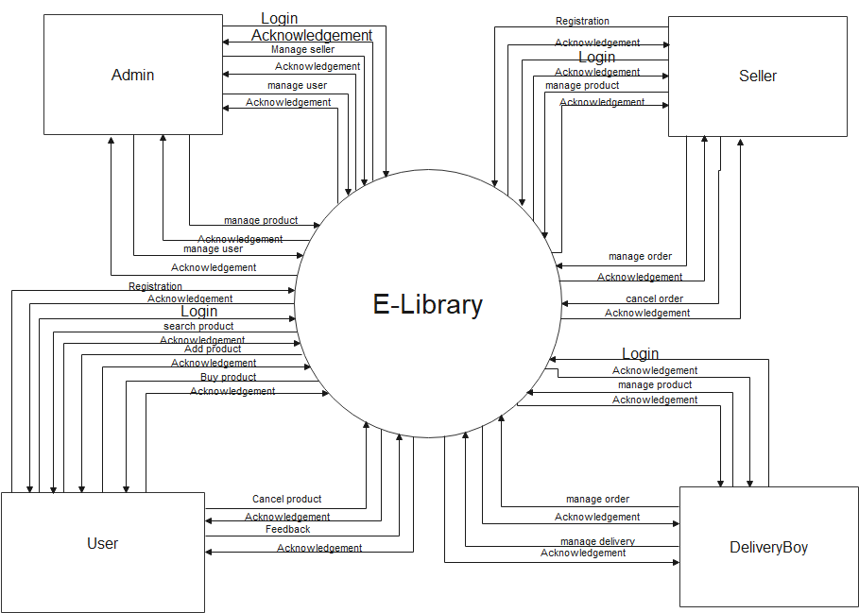

**[Figure 2: DFD Level 0 Context Diagram]**

* **DFD Level 1 Admin:-**



**[Figure 3: DFD Level 1 Admin]**

* **DFD Level 1 User:-**



**[Figure 4: DFD Level 1 User]**

* **DFD Level 1 Seller:-**



**[Figure 5: DFD Level 1 Seller]**

* **DFD Level 1 Delivery Boy:-**



**[Figure 6: DFD Level 1 Delivery Boy]**

## 3.2 E-R Diagram:

ER diagram gives the concepts of objects, attributes and relationship between objects E-R diagram can be used to model the data in the system and how the data is to be processed. It has three main elements data objects (entity), attributes and their relationship.

**[Table 3: E-R Symbols]**

|  |  |
| --- | --- |
| **Symbols** | **Description** |
|  | **Entity:** Data object is real world entity or thing. It is represented by a rectangle shape. An entity is an object or concept about which you want to store information. |
|  | **Attributes:** An attribute is property of characteristic of an entity. It is represented by oval shape. |
|  | **Relationship:** Entity are connected each other via relations. Generally, relationships in binary because there are two entities are related to each other. |
|  | **Cardinality (One to One):** An instance of entity A can relate to one instances of entity B. |

|  |  |
| --- | --- |
|  | **Cardinality (One to Many):** An instance of entity A can relate to one or many instances of B but we can only relate one instance of A. |
|  | **Cardinality (Many to One):** One or more instances of entity A can relate to one instances of B. |
|  | **Cardinality (Many to Many):** One or more instances of entity A can relate to one more instance of entity B. |

* **ER Diagram:-**



**[Figure 7: ER Diagram]**

**CHAPTER-3**

**DATA DICTIONARY**

**4.1 Database design**

# Table name: Admin

**Primary Key:** a_id

[Table 4: Admin]

|  |  |  |  |
| --- | --- | --- | --- |
| **Fields** | **Data type** | **Constraints** | **Description** |
| a_id | int(3) | Primary key | Admin’s id |
| a_username | varchar(30) | Not null | Admin's username |
| a_password | varchar(10) | Not null | Admin's password |

# Table name:Seller.

**Primary Key:** s**_**id.

[Table 5: Seller]

|  |  |  |  |
| --- | --- | --- | --- |
| **Fields** | **Data type** | **Constraints** | **Description** |
| s_id | int(3) | Primary key | Contains Seller’s id. |
| s_username | varchar(30) | Not null | Contains Seller’s name. |
| s_contactno | int(10) | Not null | Contains Seller's contact-number. |
| s_password | varchar(10) | Not null | Contains Seller’s password. |
| s_gstno | int(15) | Null | Contains seller’s gst number. |
| s_address | varchar(150) | Not null | Contains Seller’s address. |
| s_email | varchar(20) | Not null | Contains Seller’s email address. |

# Table name: Customer

**Primary Key:** c_id

[Table 6: User]

|  |  |  |  |
| --- | --- | --- | --- |
| **Fields** | **Data type** | **Constrains** | **Description** |
| c_id | int(8) | Primary key | Customer’s id |
| Fullname | varchar(50) | Not null | Contains the Customer's full name |
| c_email | varchar(20) | Not null | Contains the Customer's email address |
| c_password | varchar(10) | Not null | Contains the Customer's password |
| c_contactno | int(10) | Not null | Contains the Customer's number |
| c_address | varchar(150) | Not null | Contains the Customer's address |

# Table name: DeliveryBoy

**Primary Key:** db_id

**Foreign Key:** o_id

[Table7: DeliveryBoy]

|  |  |  |  |
| --- | --- | --- | --- |
| **Fields** | **Data type** | **Constrains** | **Description** |
| db_id | int(3) | Primary key | Delivery Boy’s id |
| db_username | varchar(30) | Not null | Delivery Boy's username |
| db_password | varchar(10) | Not null | Delivery Boy's password |
| db_contactno | int(10) | Not null | Delivery Boy’s Contact number |
| db_age | int(3) | Not null | Delivery Boy’s age |
| db_address | varchar(150) | Not null | Contains Delivery Boy’s address. |
| o_id | int(3) | Foreign key | Order id. |

## Table name: Bookdetails

**Primary Key:** b_id

Foreign key: s_id

[Table 10: productdetails]

|  |  |  |  |
| --- | --- | --- | --- |
| **Fields** | **Data type** | **Constrains** | **Description** |
| b_id | int(3) | Primary key | Stores the productid |
| b_name | varchar(20) | Not null | Name of the book will be stored here |
| b_details | Longtext | Not null | This will contain the book  Details |
| s_id | int(3) | Foreign key | This will contain seller’s id. |
| Price | int(5) | Not null | The visit price will be stored here |
| image1 | varchar(10) | Not null | This will have The path of the first image. |
| image2 | varchar(10) | null | This will have the path of the second image |
| image3 | varchar(10) | null | This will have the path of the third image |
| image4 | varchar(10) | null | This Will store the path of the fourth image |
| image5 | varchar(10) | Not null | This Will store the path of the fifth image |

1. Table name: Orderdetails

**Primary Key:** order_id

Foreign key: b_id, s_id, u_id

**[Table 12: Order details]**

|  |  |  |  |
| --- | --- | --- | --- |
| **Fields** | **Data type** | **Constrains** | **Description** |
| order_id | int(3) | Primary key | Stores the Order id |
| b_id | int(3) | Foreign key | Book id |
| s_id | int(3) | Foreign key | Seller id |
| u_id | int(3) | Foreign key | User id |
| order_details | varchar(20) | Not null | Contains order details |

1. Table name:Cancellation

## Primary Key: cs_id

**Foreign Key:** u_id, p_id, s_id

**[Table 13: Cancellation]**

|  |  |  |  |
| --- | --- | --- | --- |
| **Fields** | **Data type** | **Constrains** | **Description** |
| cs_id | int(3) | Primary key | Cancellation_id |
| u_id | int(3) | Foreign key | User id |
| b_id | int(3) | Foreign key | Book id |
| s_id | int(3) | Foreign key | Seller id |
| cancellation_reason | Mediumtext | Not null | Cancellation reason |

1. **Table name: Return**

**Primary key:** Return_id

**Foreign Key:** u_id, b_id, s_id

**[Table 14: Return]**

|  |  |  |  |
| --- | --- | --- | --- |
| **Fields** | **Data type** | **Constrains** | **Description** |
| return_id | int(3) | Primary key | return_id |
| u_id | int(3) | Foreign key | User id |
| b_id | int(3) | Foreign key | Book id |
| s_id | int(3) | Foreign key | Seller id |
| returning_reason | Mediumtext | Not null | Cancellation reason |

1. Table name:Feedback

## Primary Key: fb_id

**Foreign Key:** u_id

**[Table 15: Feedback]**

|  |  |  |  |
| --- | --- | --- | --- |
| **Fields** | **Data type** | **Constrains** | **Description** |
| f_Id | Int(3) | Primary key | Feedback id |
| u_id | Int(3) | Foreign key | User id |
| feedbacksubject | Varchar(20) | Not null | Feedback subject |
| feedbackmessage | Mediumtext | Not null | Feedback message |
| Postingdate | Timestamp | Not null | Store the posting date of the feedback |

**CHAPTER 3**

**TECHNICAL SPECIFICATION**

# Hardware Specification:

# RAM:

* + - * Client RAM requirement: 4GB

## Hard drive storage needed:

## Client Hard drive requirements:200GB

## Other Hardware Requirements:

## Printer

* 1. **Platform:**

## Supported Operating System:

* Supported Operating System: Windows 7 or above, mac, Linux

## Programming Server:

* Apache2.4.46

## Framework

* Django

# Programming Languages Used:

## Markup Language:

* HTML 4.0,5.0 and CSS

## Programming Language:

* Python

## Scripting Language:

# JavaScript

# Technical Specification:

## Front-End:

* HTML5.0 for layout and CSS3 for designing.

## Back-End:

* MySQL & Django.

## IDE:

* Visual Studio Code

## UML Tools:

* Edrawmax

## SRS Tools:

* Microsoft word 2007 and above.

# Design Layout:

# 

**Figure 1: Admin login]**

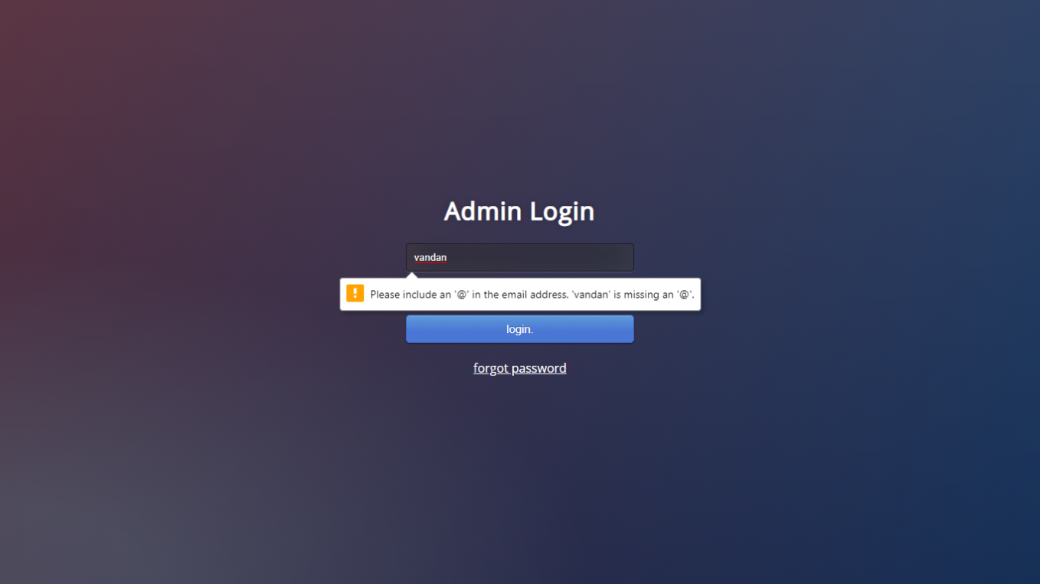

**Figure: Admin login with validation]**

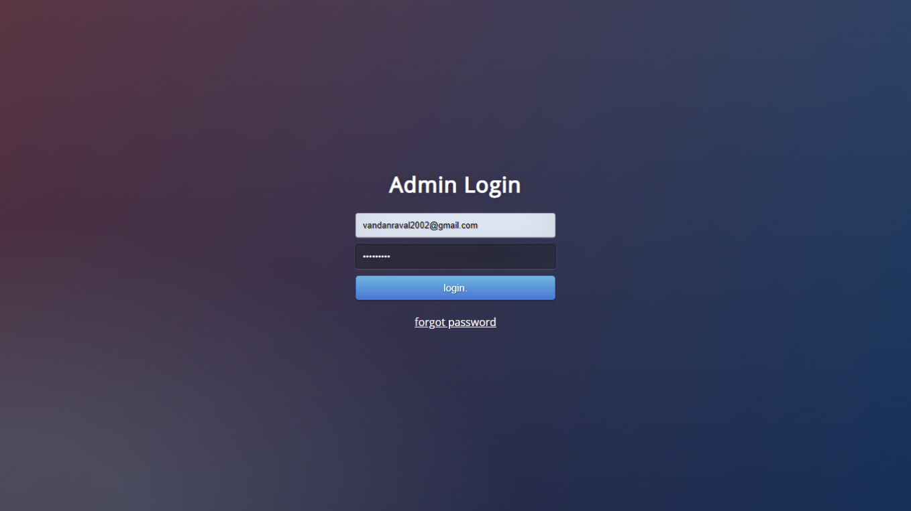

[Figure: Admin login with proper details]

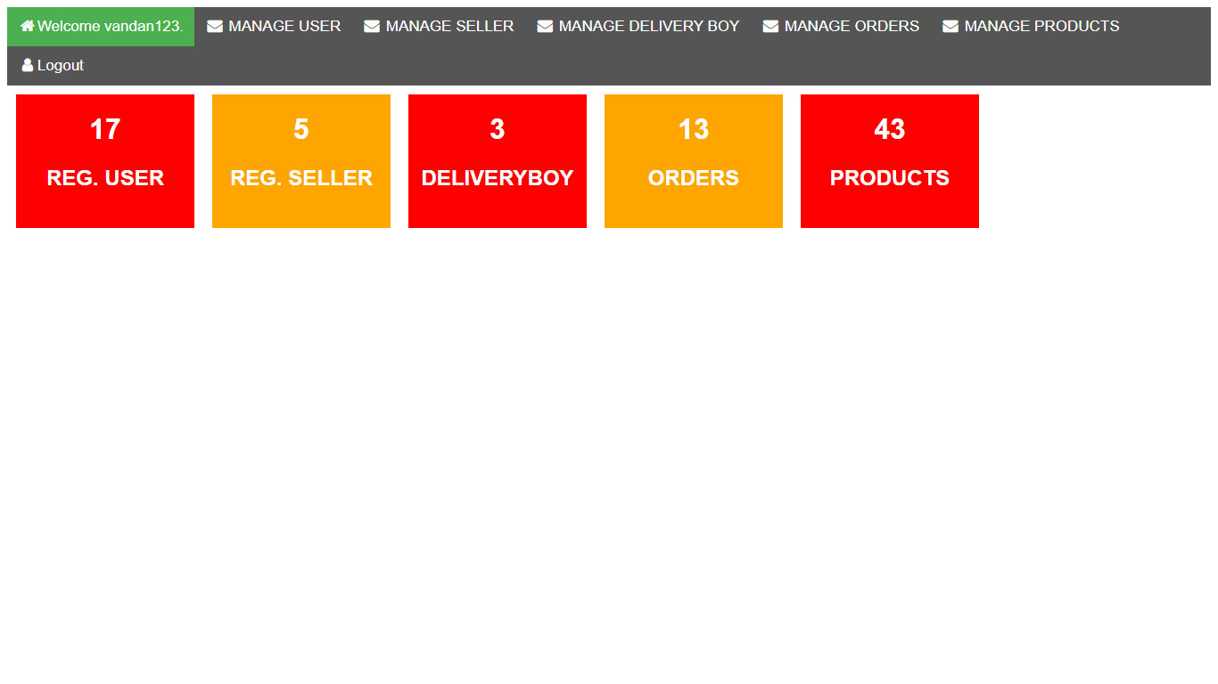

[Figure: **Dashboard in admin panel**]

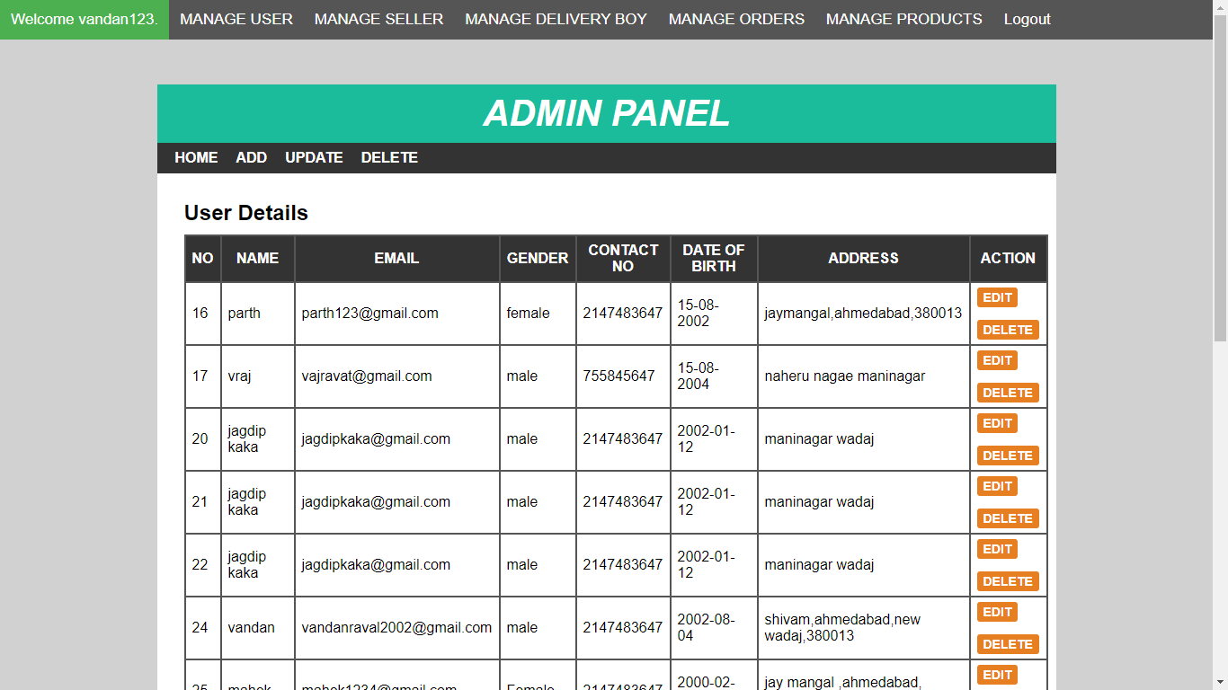

[Figure: **Display user information in admin panel**]

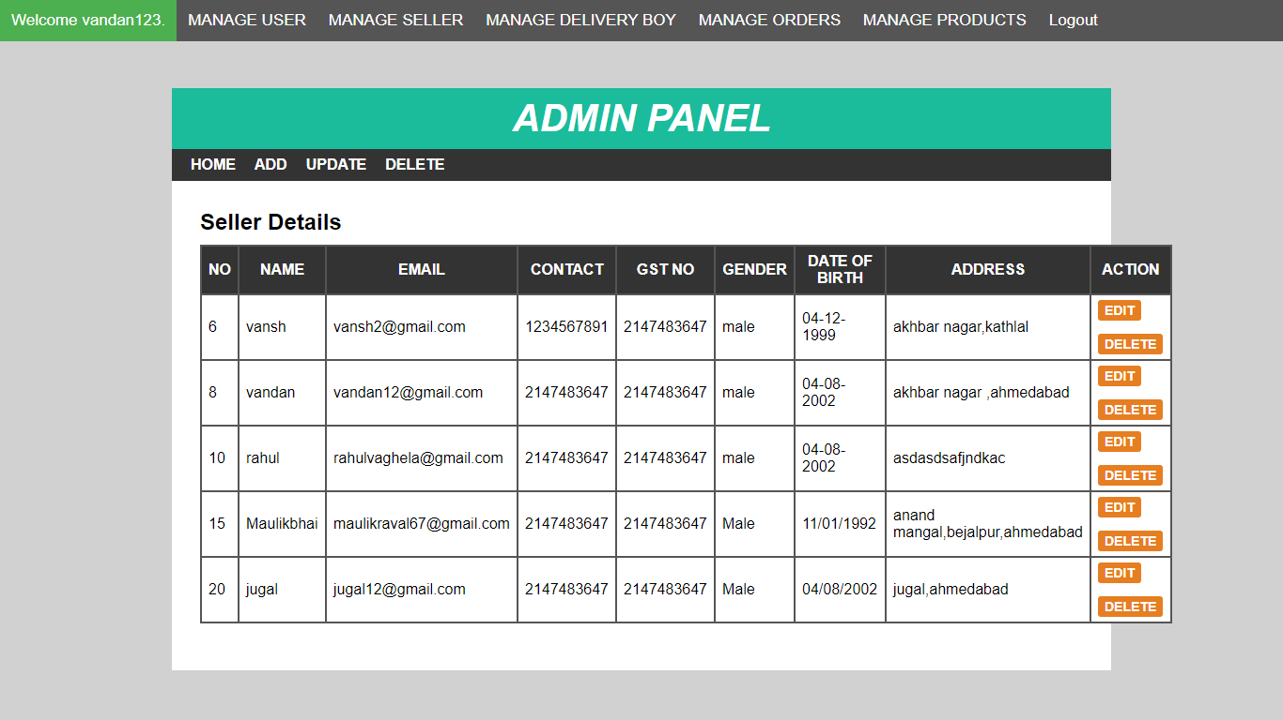

[Figure: **Display seller information in admin panel**]

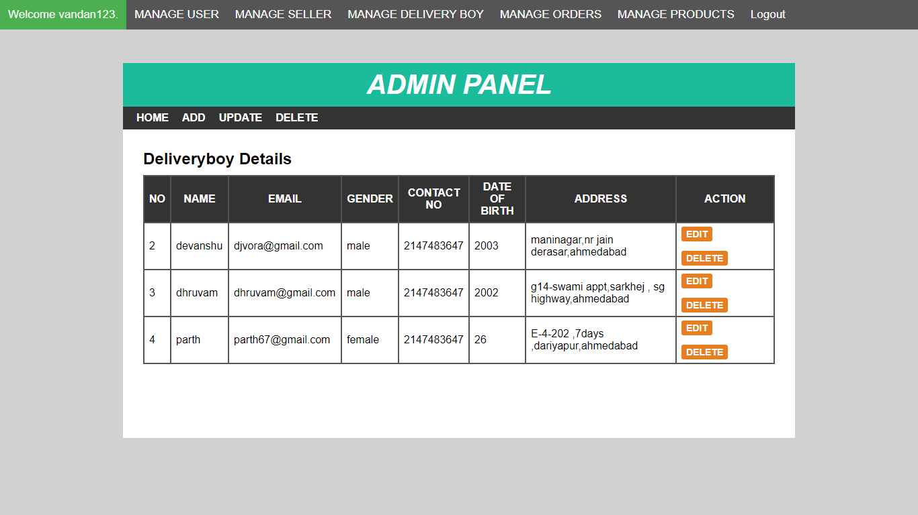

[Figure: **Display delivery boy information in admin panel**]

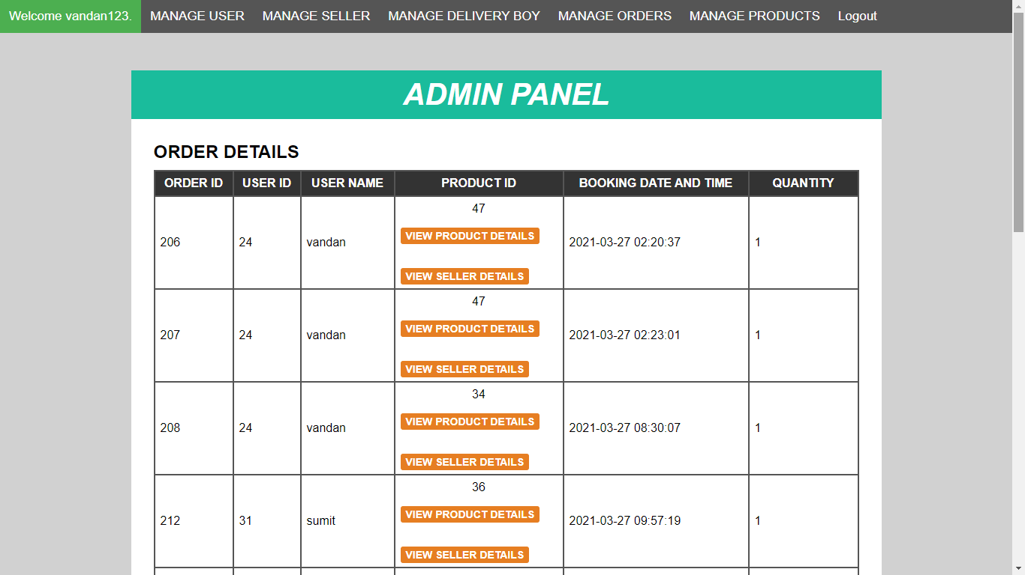

[Figure: **Display Order information in admin panel**]

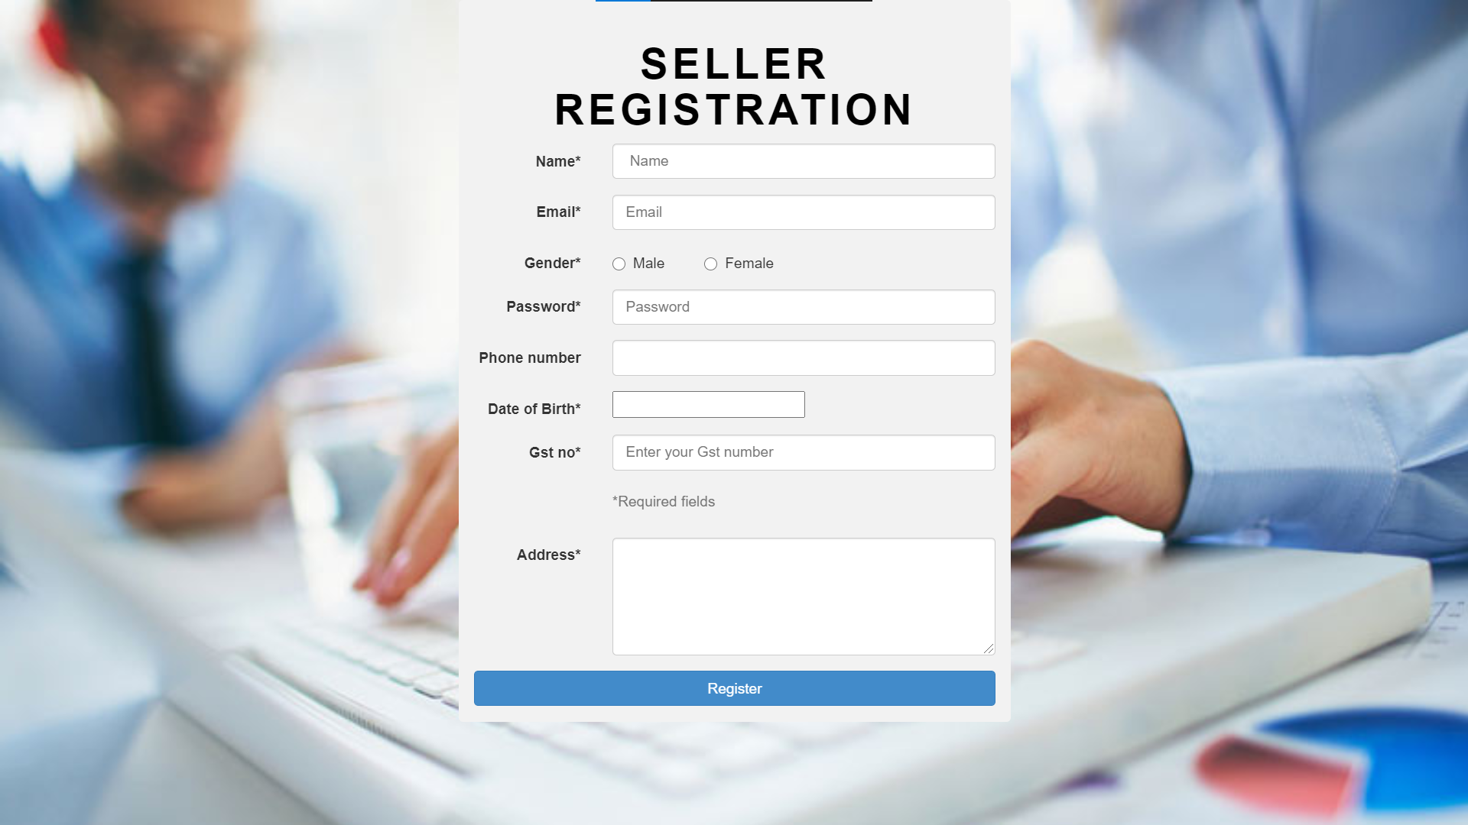

[Figure: Seller registration]

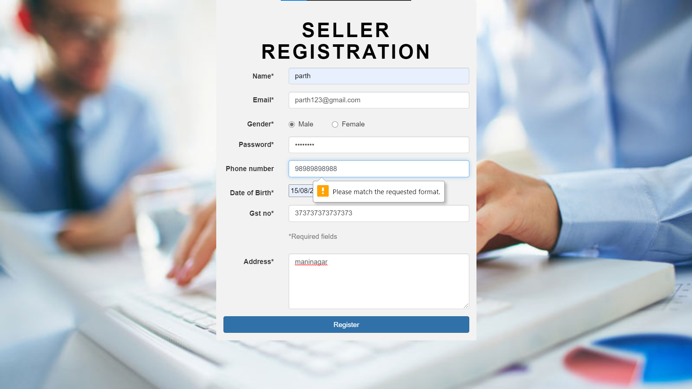

[Figure 12: Seller registration with validation]

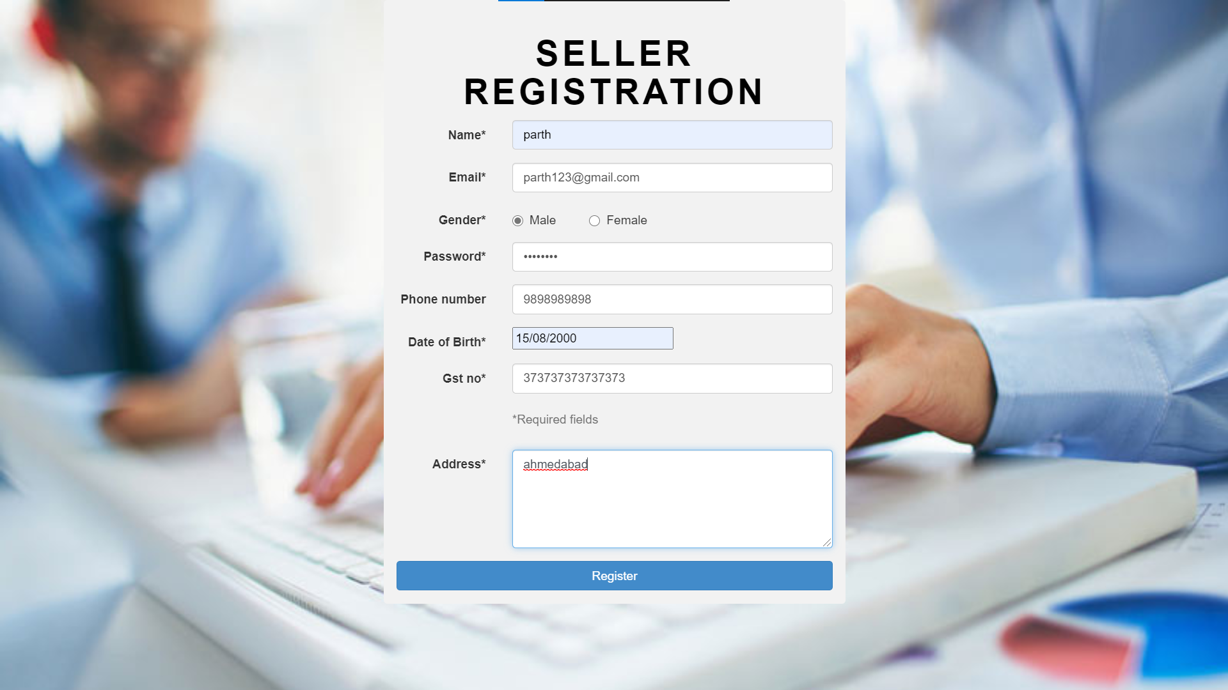

[Figure: Seller registration with proper details]

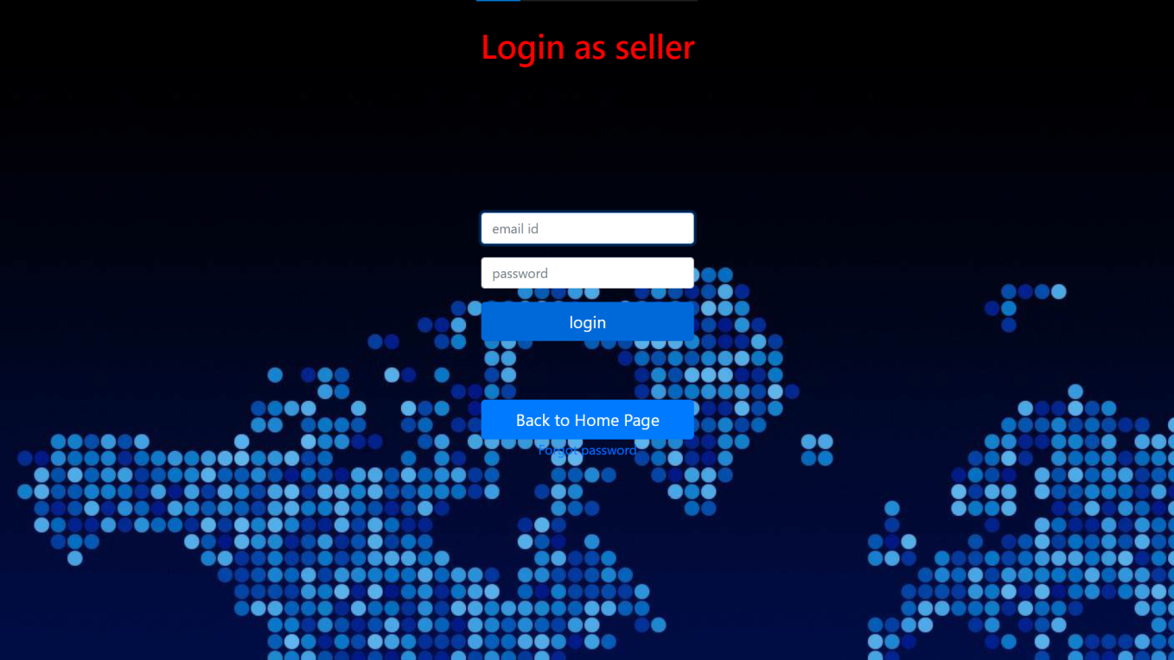

[Figure: Seller login]

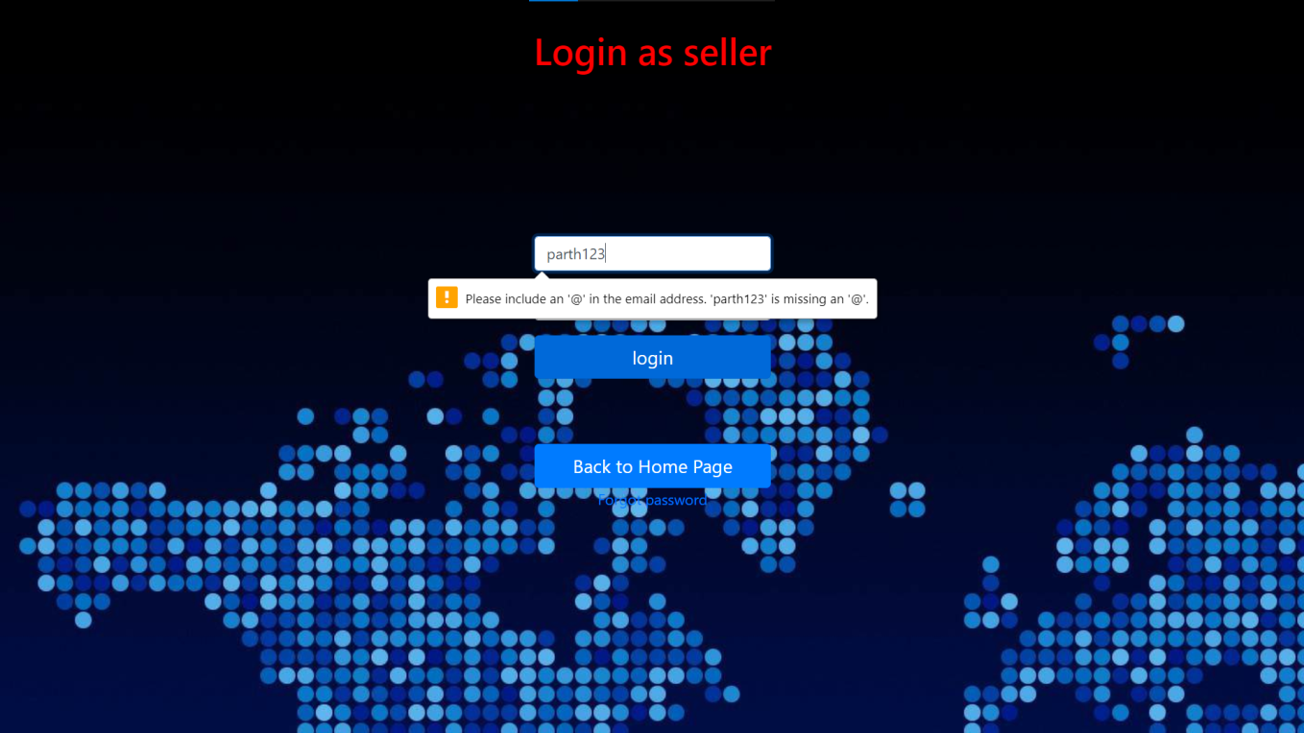

[Figure: Seller login with validation]

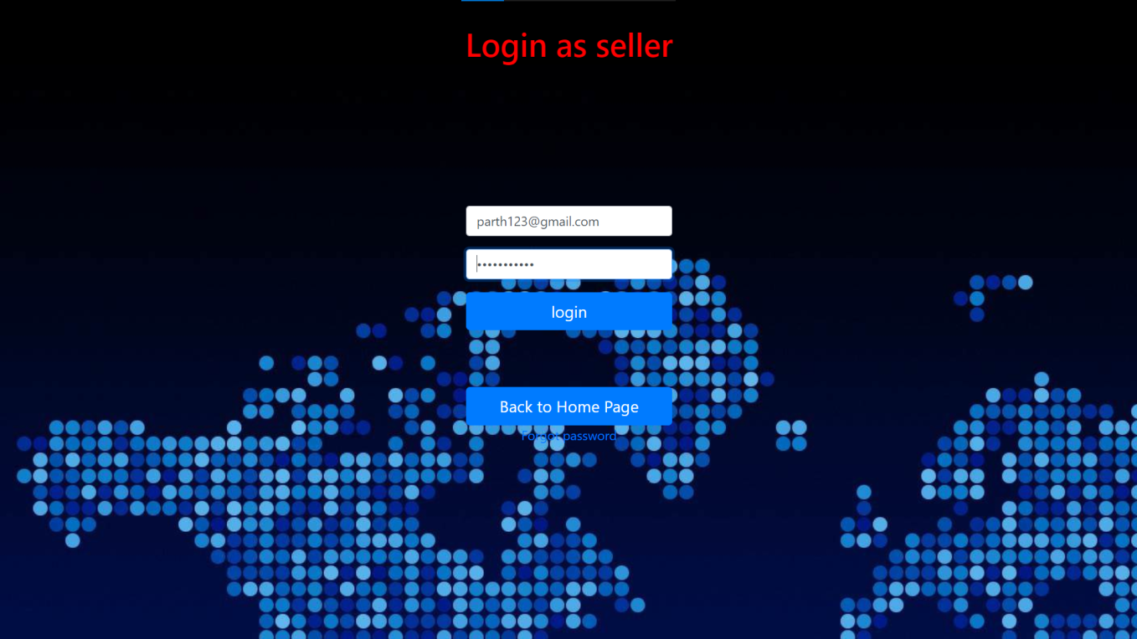

[Figure: Seller login with proper details]

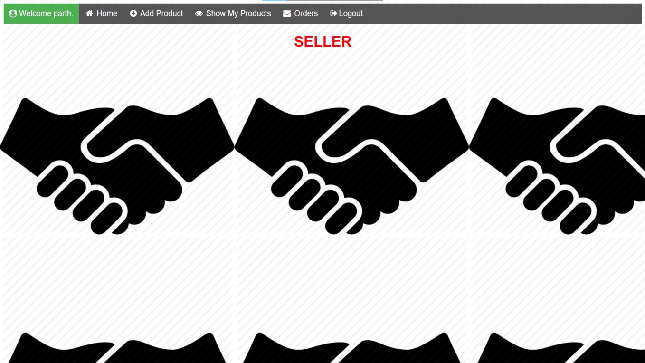

[Figure: Seller Dashboard]

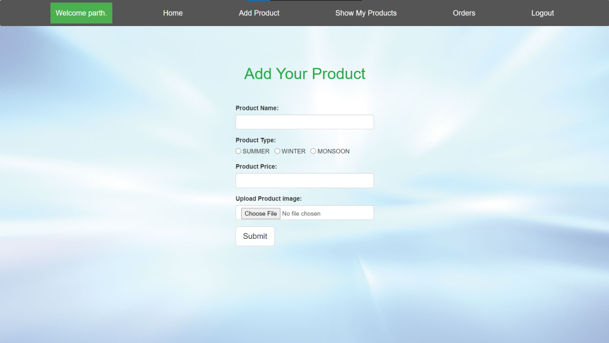

[Figure: Add Product Page of Seller Dashboard]

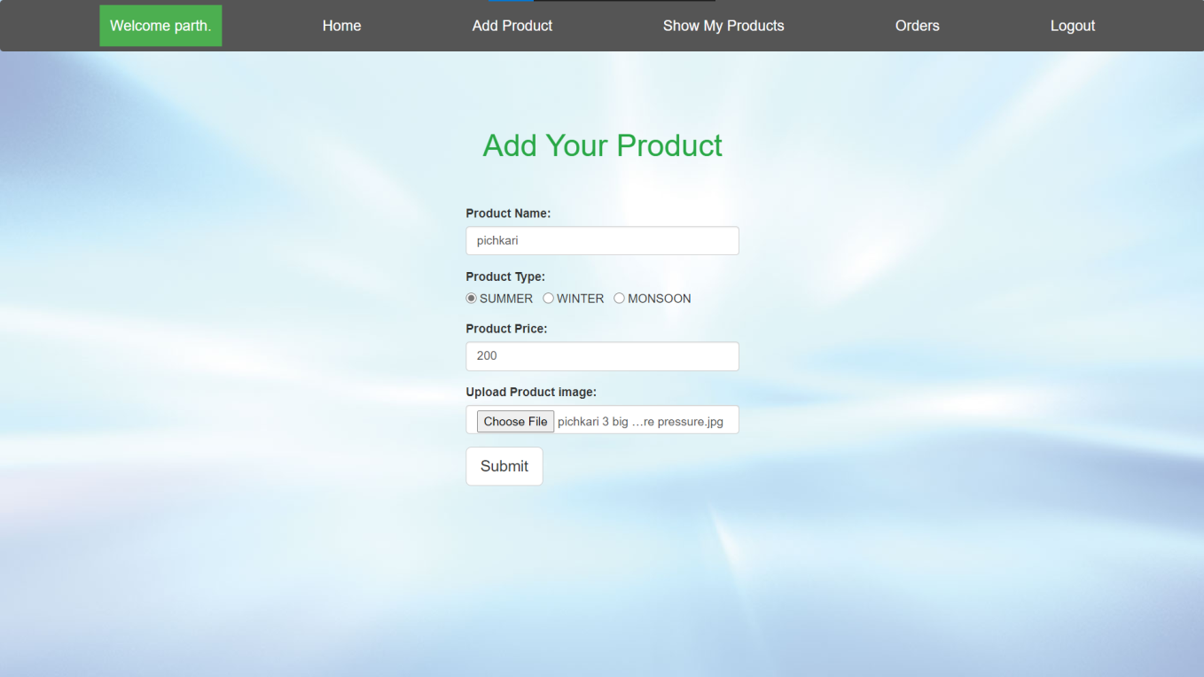

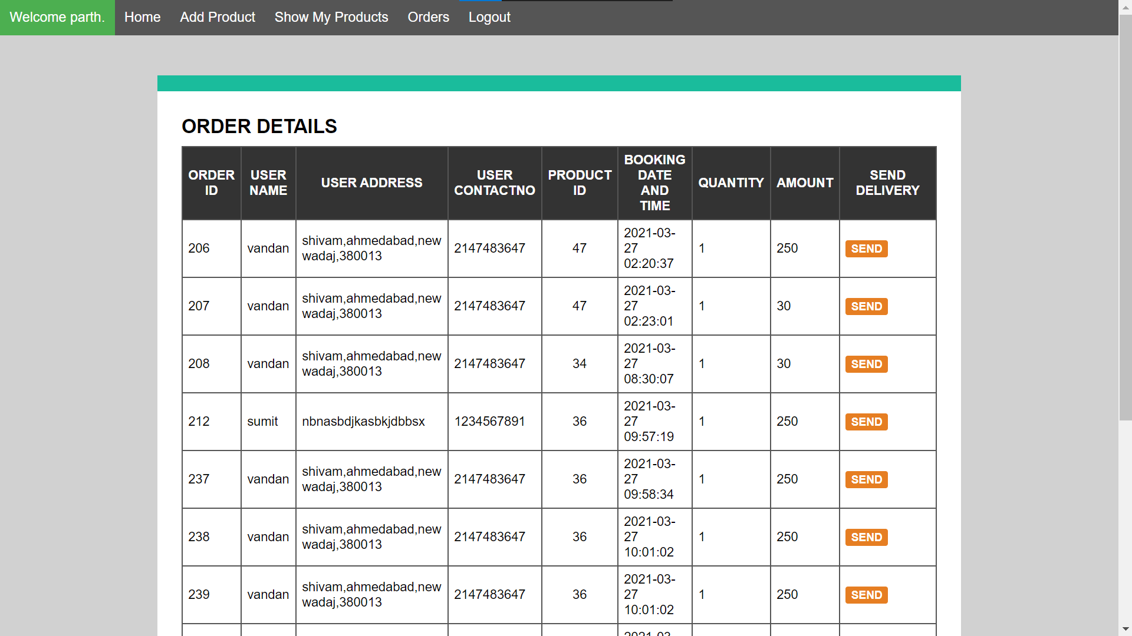

[Figure: Order Details Page of Seller Dashboard]

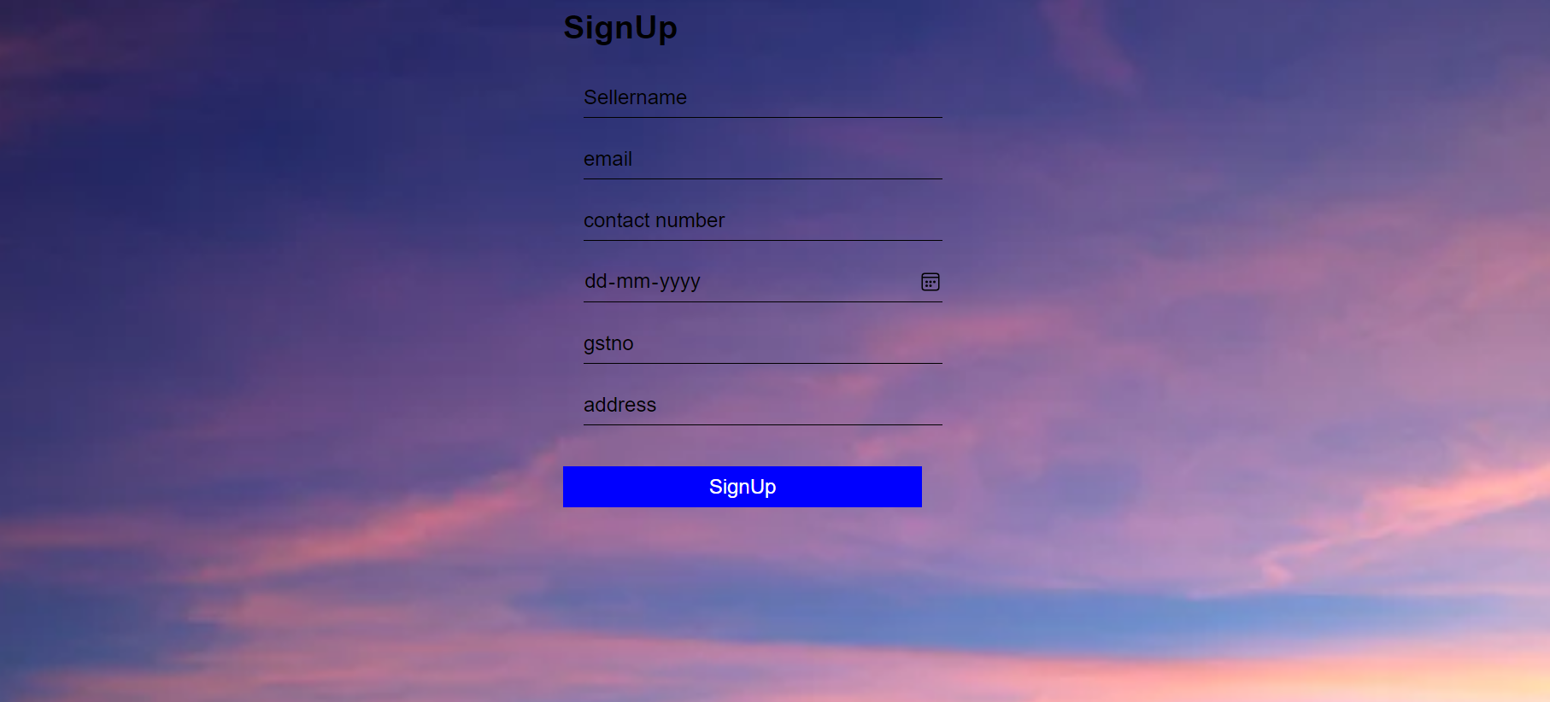

[Figure: User registration]

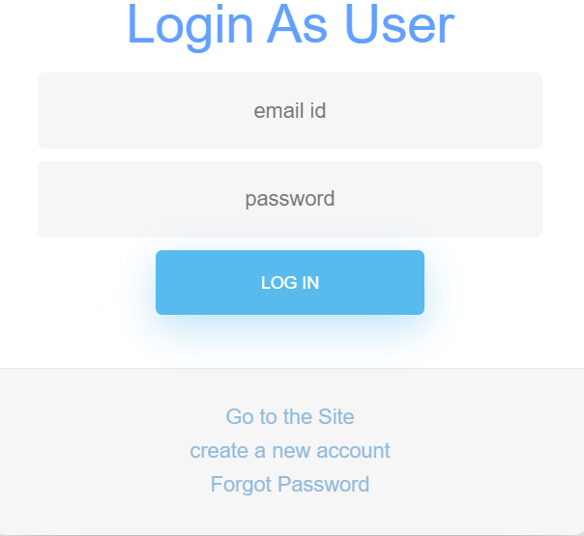

[Figure: User login]

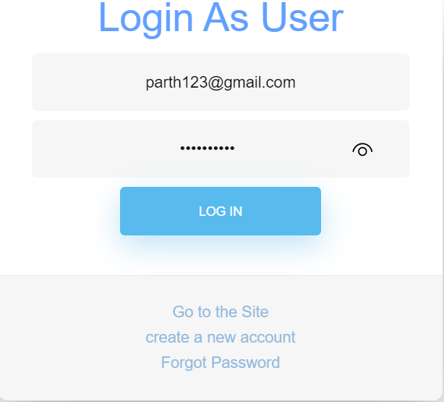

[Figure: User login with proper details]

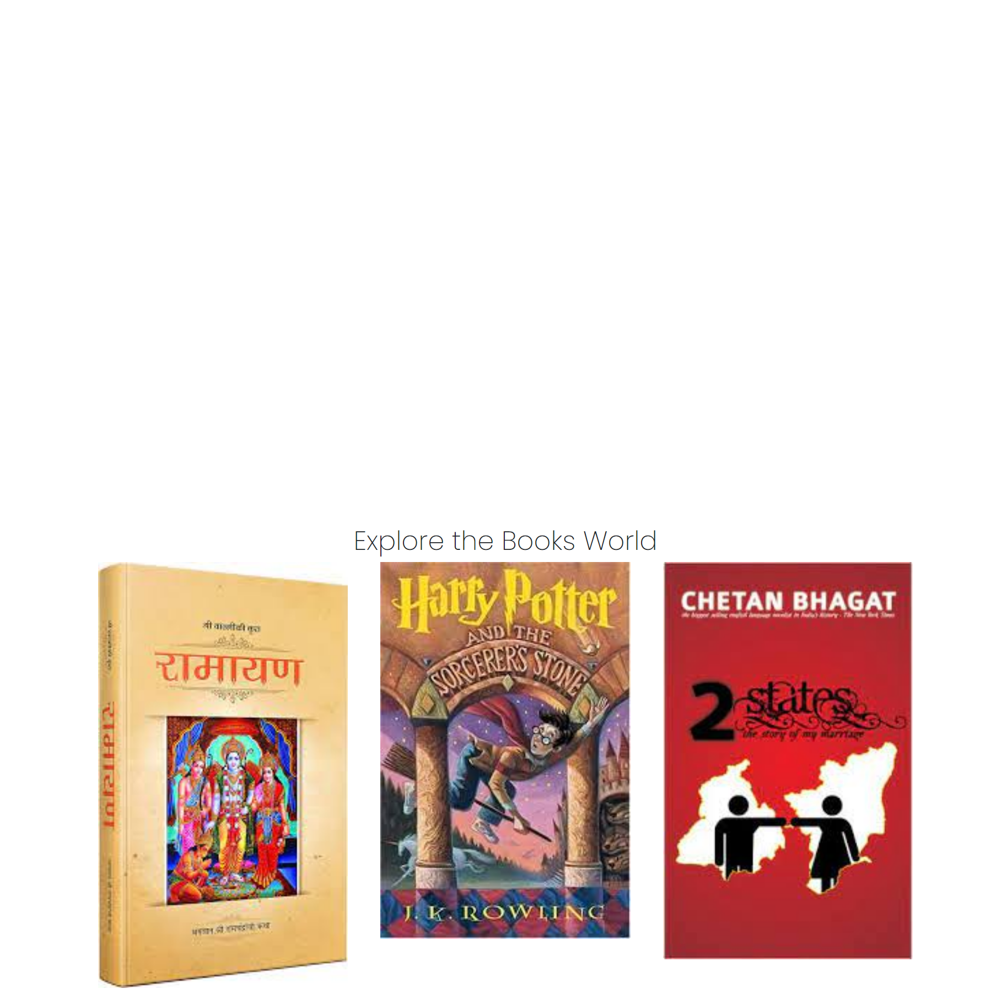

[Figure: Home Page after user logged in]

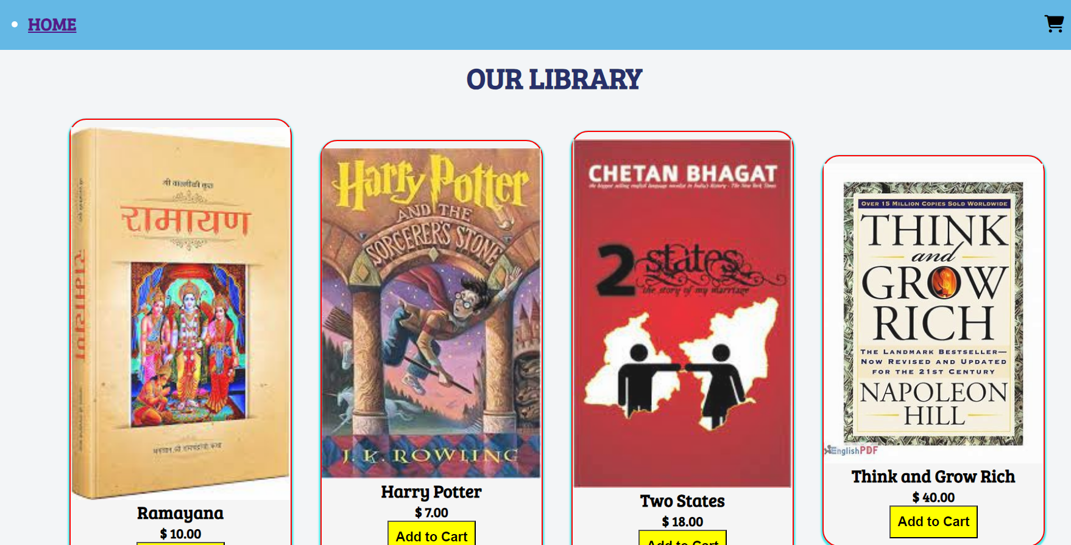

[Figure: Product Page]

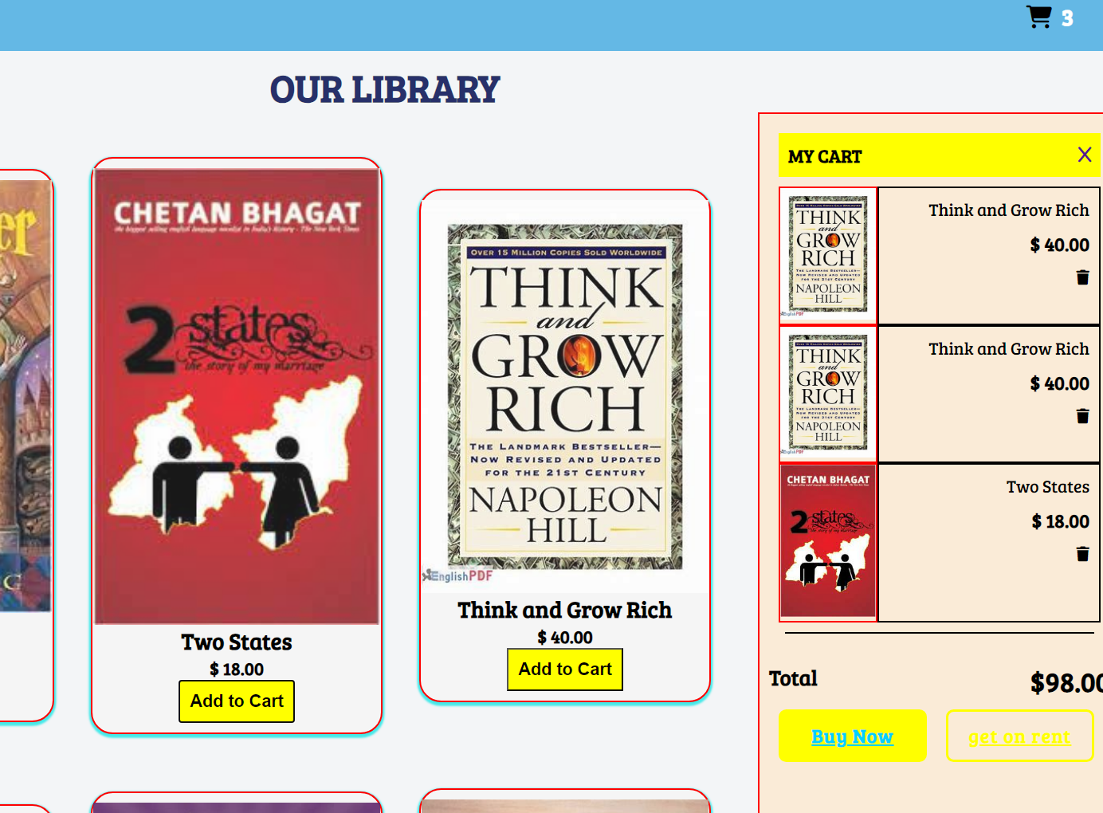

[Figure: Shopping Cart]

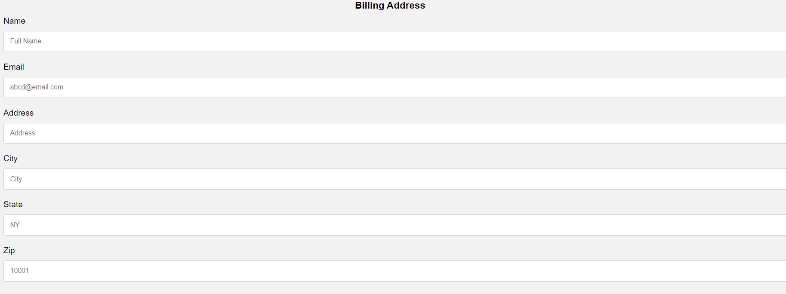

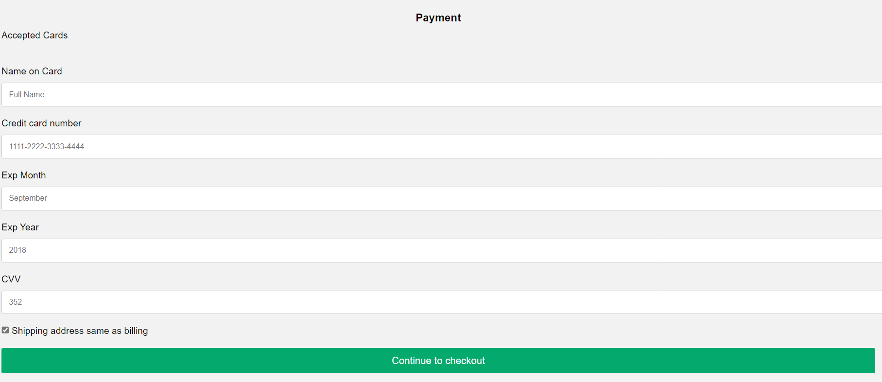

[Figure: Payment Page]

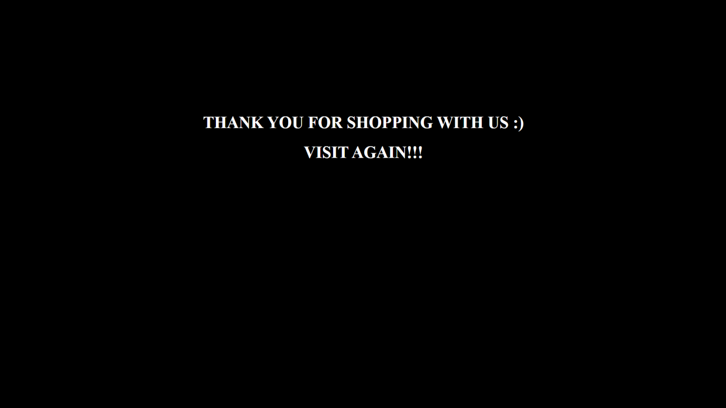

[Figure: Thank You Page]

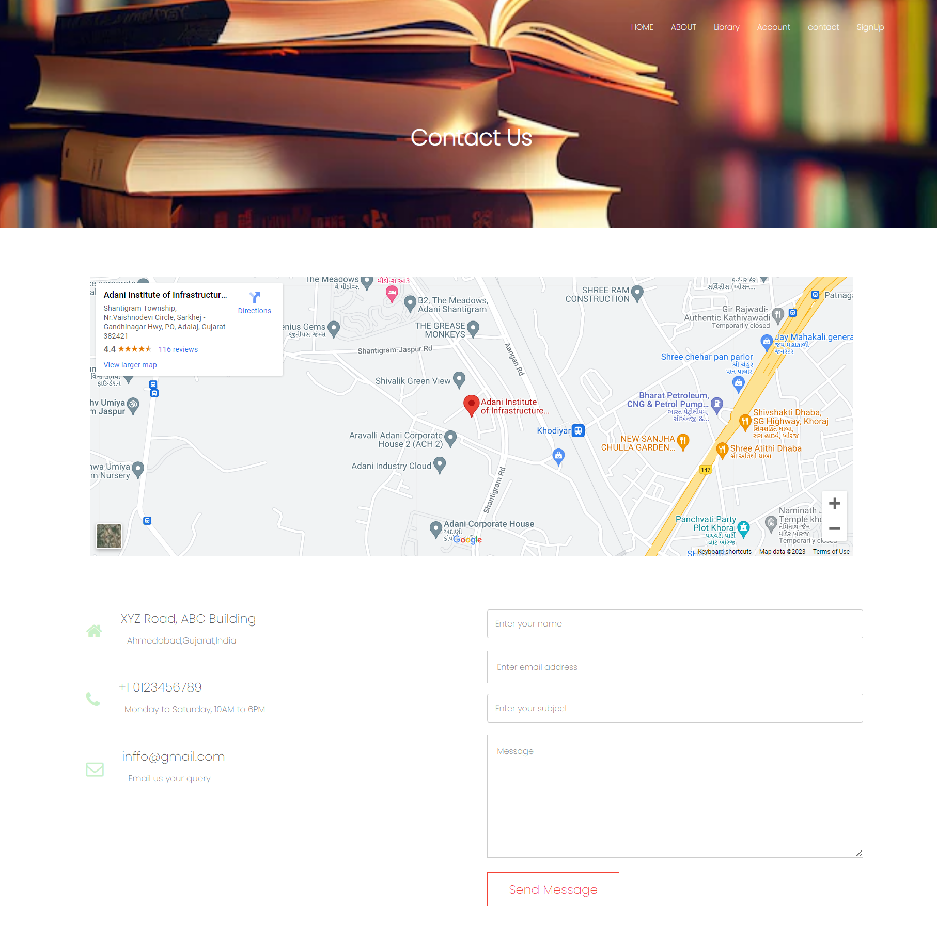

[Figure: Contact us]

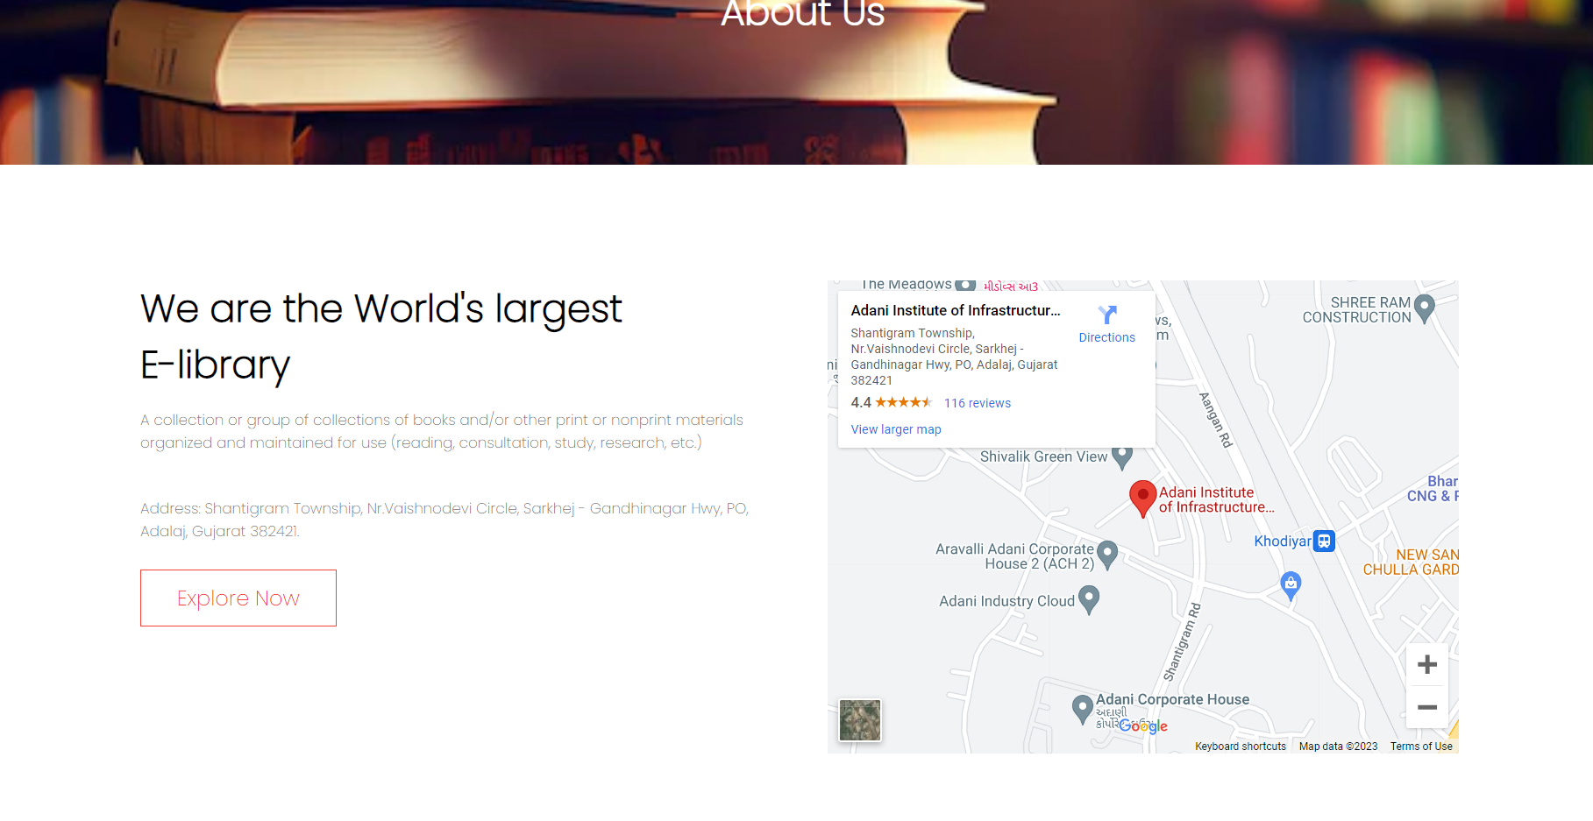

[Figure: About Page]

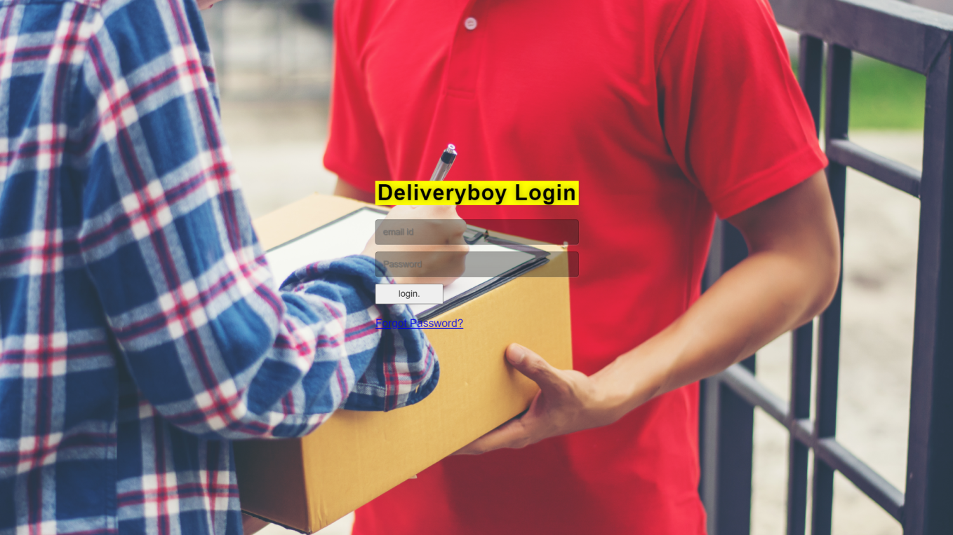

[Figure: Delivery Boy login]

**CHAPTER 6**

**TESTING**

# Testing Methods

Testing is necessary because we all make mistakes. Some of those mistakes are minor, but some of them are expensive or dangerous. We need to go through every component that we develop before presenting it in front of our customers because things can always go wrong.

Quality of software should be reasonably bug or defect-free, delivered on time and within budget, meets the requirement, and must be sustainable. Software testing is a process of executing a program or application with the intent of finding the software bug.

It can also be stated as the process of validating and verifying that a software program or application or product must be:

* Meets the technical requirements.
* Works as expected.
* 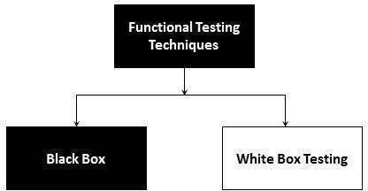Can be implemented with the same characteristic.

**Figure 9:[Functional Testing Techniques]**

# White Box Testing

White Box Testing (also known as Clear Box Testing, Open Box Testing, Glass Box Testing, Transparent Box Testing, Code-Based Testing, or Structural Testing) is a software testing method in which the internal structure/design/implementation of the item being tested is known to the tester. The tester chooses inputs to exercise paths through the code and determines the appropriate outputs. Programming know-how and implementation knowledge are essential. White box testing is testing beyond the user interface and into the nitty-gritty of a system.

In white-box testing, an internal perspective of the system, as well as programming skills, are used to design test cases. It can test paths within a unit, paths between units during integration, and between subsystems during a system–level test.

This method is named so because the software program, in the eyes of the tester, is like a white/transparent box inside which one clearly sees.

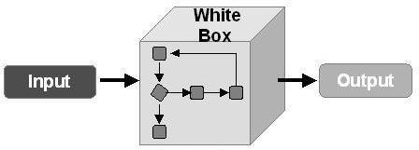

**Figure 9: [White Box Testing]**

# 6.1.1.1 Pros of White Box Testing

* + Forces test developer to reason carefully about implementation.
  + Side effects of having the knowledge of source code is beneficial to testing.
  + Testing is more thorough, with the possibility of covering most paths.
  + Reveals errors in hidden codes.
  + It helps in optimizing the code.
  + Extra lines can be removed which can bring in hidden defects.
  + Data domains and internal boundaries can be better tested.

# 6.1.1.2 Cons of White Box Testing

* + Expensive as one must spend both time and money to perform white box testing.
  + Every possibility that a few lines of code are missed accidentally.
  + In-depth knowledge of the programming language is necessary to perform white box testing.
  + White-box testing brings complexity to testing because the tester must have knowledge of the program, including being a programmer. White-box testing requires a programmer with a high level of knowledge due to the complexity of the level of testing that needs to be done.
  + The tests focus on the software as it exists, and missing functionality may not be discovered.
  + Test script maintenance can be a burden if the implementation changes too frequently.

# Black Box Testing

BLACK BOX TESTING, also known as behavioral Testing, is a software testing method in which the internal structure/design/implementation of the item being tested is not known to the tester. These tests can be functional or non-functional, though usually functional.

Black-box testing is a method of software testing that examines the functionality of an application without peering into its internal structures or

workings. It is sometimes referred to as specification-based testing. This

method is named so because the software program, in the eyes of the tester, is like a black box inside which one cannot see.

This method attempts to find errors in the following categories:

* + Incorrect or missing functions
  + Interface errors
  + Errors in data structures or external database access
  + Behavior or performance errors
  + Initialization and termination errors

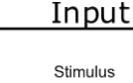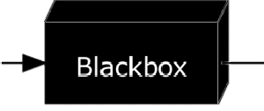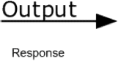

**Figure 10:[Black Box Testing]**

# Pros of Black Box Testing

* Tests are done from a user’s point of view and will help in exposing discrepancies in the specifications.
* Tester need not know programming languages or how the software has been implemented.
* Tests can be conducted by a body independent from the developers, allowing for an objective perspective and the avoidance of developer- bias.
* Test cases can be designed as soon as the specifications are complete.
* Testers and Programmers are independent of each other tests are done from the user’s point of view.
* Code access is not required.
* It is well-suited and efficient for large code segments.

# 6.1.2.2 Cons of Black Box Testing

* Only a small number of possible inputs can be tested and many program paths will be left untested.
* Without clear specifications, which is the situation in many projects, test cases will be difficult to design.
* Tests can be redundant if the software designer/developer has already run a test case.
* Blind Coverage, since the tester cannot target specific code segments or error prone area
* No systemic search for low level errors.

**CONCLUSION**

The E-Library was developed using HTML, CSS, and other development languages, and fully meets the objectives of the system for which it has been partially developed. The system is operated at a high level of efficiency and all the users and sellers associated with the system understands its advantage. The system solves the problem. It was intended to solve a requirement specification.

**ACKNOWLEDGEMENT**

We would thank our faculty members & IQM Team, whose valuable guidance has been a success, their suggestion and their instructions have served as the major contributor towards the completion of the project.

Then we would also like to thank our parents for always giving us support and encouragement, so which has been helpful in various phases of the completion of the project.

**Darshil Shah (201310132127)**

**Devanshu Vora(211310132501)**

**Feni Suchak (201310132140)**

**Riddhi Jayswal(211310132010)**